|  |
| --- |
| 1.jpg  **Assessment Cover Sheet** |

**Due Date**

21-05-2024

**Course Code**

IT8415

**Assessment Title**

Group Project

**Course Title**

Database Programming 2

**Internal Moderator’s Name**

Karim Ahmed

**External Examiner’s Name**

-

Not must-pass

Group 5

Uncontrolled

**Assessment Type**

1. **Instructions:**
2. 1. This cover sheet must be completed (section in red below) and attached to your assessment before
3. submission in hard copy/soft copy.
4. 2. This assessment carries 100 marks and assessing CILO 1 and CILO 2.
5. 3. The **use of generative AI tools is strictly prohibited**.
6. 4. References consulted (if any) must be properly acknowledged and cited.
7. 5. The assessment has a total of 11 pages.

**Programme Title**

**Learner ID**

**Date Submitted**

23-05-2024

**Students Name**

Bachelor of Information and Communications Technology (Database System/ Programming) ICT8040/ICT8010

202000270 – 202002514 – 201901982 – 202003580 - 202002172

Amena Almohanna – Fedaa Abdulwahab – Maryam Alali - Sara Abdulrahman – Ebtisam Alanfooz

**Students ID**

**Lecturer’s Name**

Saba Mustafa

***By submitting this assessment for marking, I affirm that this assessment is my own work.***

**Learner Signature**

Do not write beyond this line. For assessor use only.

**Assessor’s Name**

**Marking Date**

**Maks Obtained**

**Comments:**

**Contents**

**Introduction** 3

**A URL for the completed application** 3

**Application functionality** 3

Functional Requirements 3

Log In & Sign-Up: Potential Users of the Online Portal 3

Online website 14

Non-Functional Requirements 15

**• Navigation** 15

**• Pagination** 15

**• Look and feel** 15

**• Validation of input** 16

**• Extra printing** 17

**Database** 18

Procedure 18

DB Security techniques used 21

**Users for testing** 21

**Test Data** 22

**Advanced features used** 22

# **Introduction**

This project involves developing a website for Orient Event Organizer Ltd (OEO) company that specializes in arranging events, services, and catering using PHP, HTML, CSS and JavaScript. The events can be held in a seminar hall with an audience capacity of 80, three small halls with a capacity of 30 people and a lab consisting of 40 desktop computers.

# **A URL for the completed application**

<http://20.126.5.244/~u202002172/index.php>

# **Application functionality**

## Functional Requirements

### Log In & Sign-Up: Potential Users of the Online Portal

The website includes three types of users:

1. **Administrator**

-Log in.

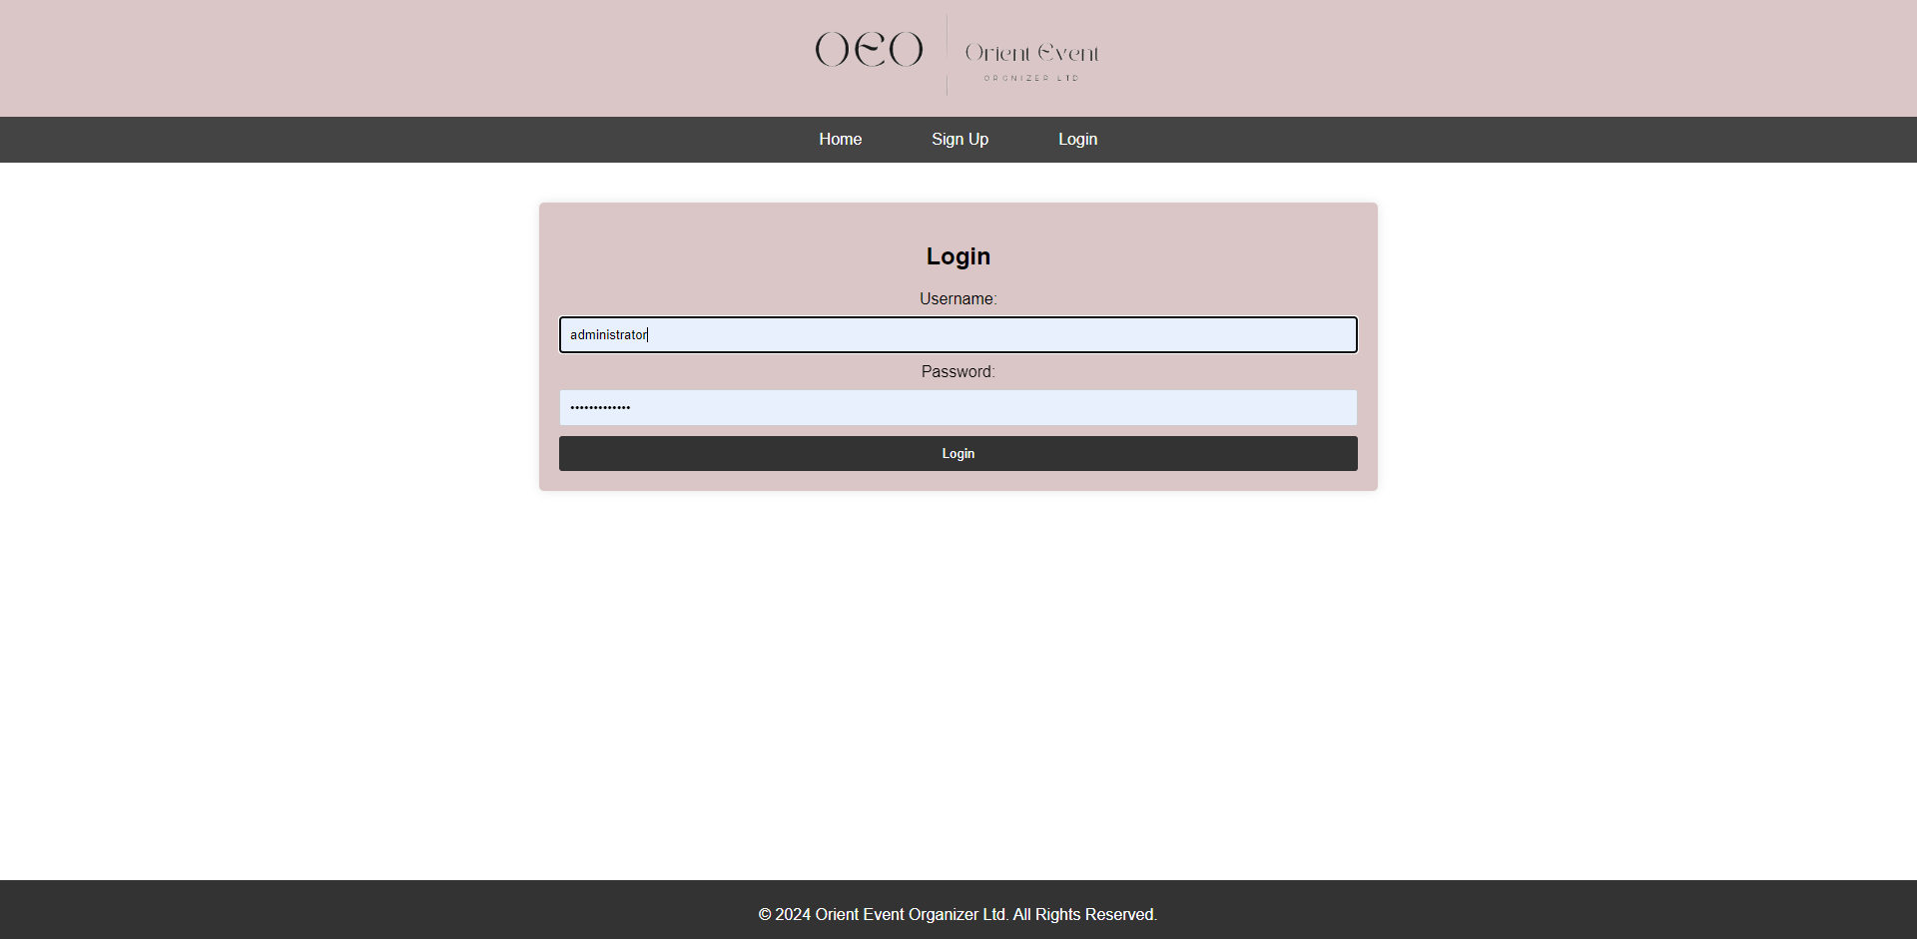

-Manage and View all Employee details (add/Edit/Delete)

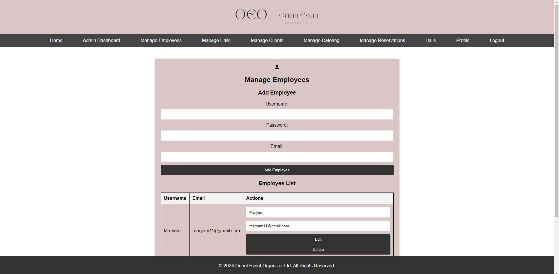

-Manage and View all Halls details (add/Edit/Remove)

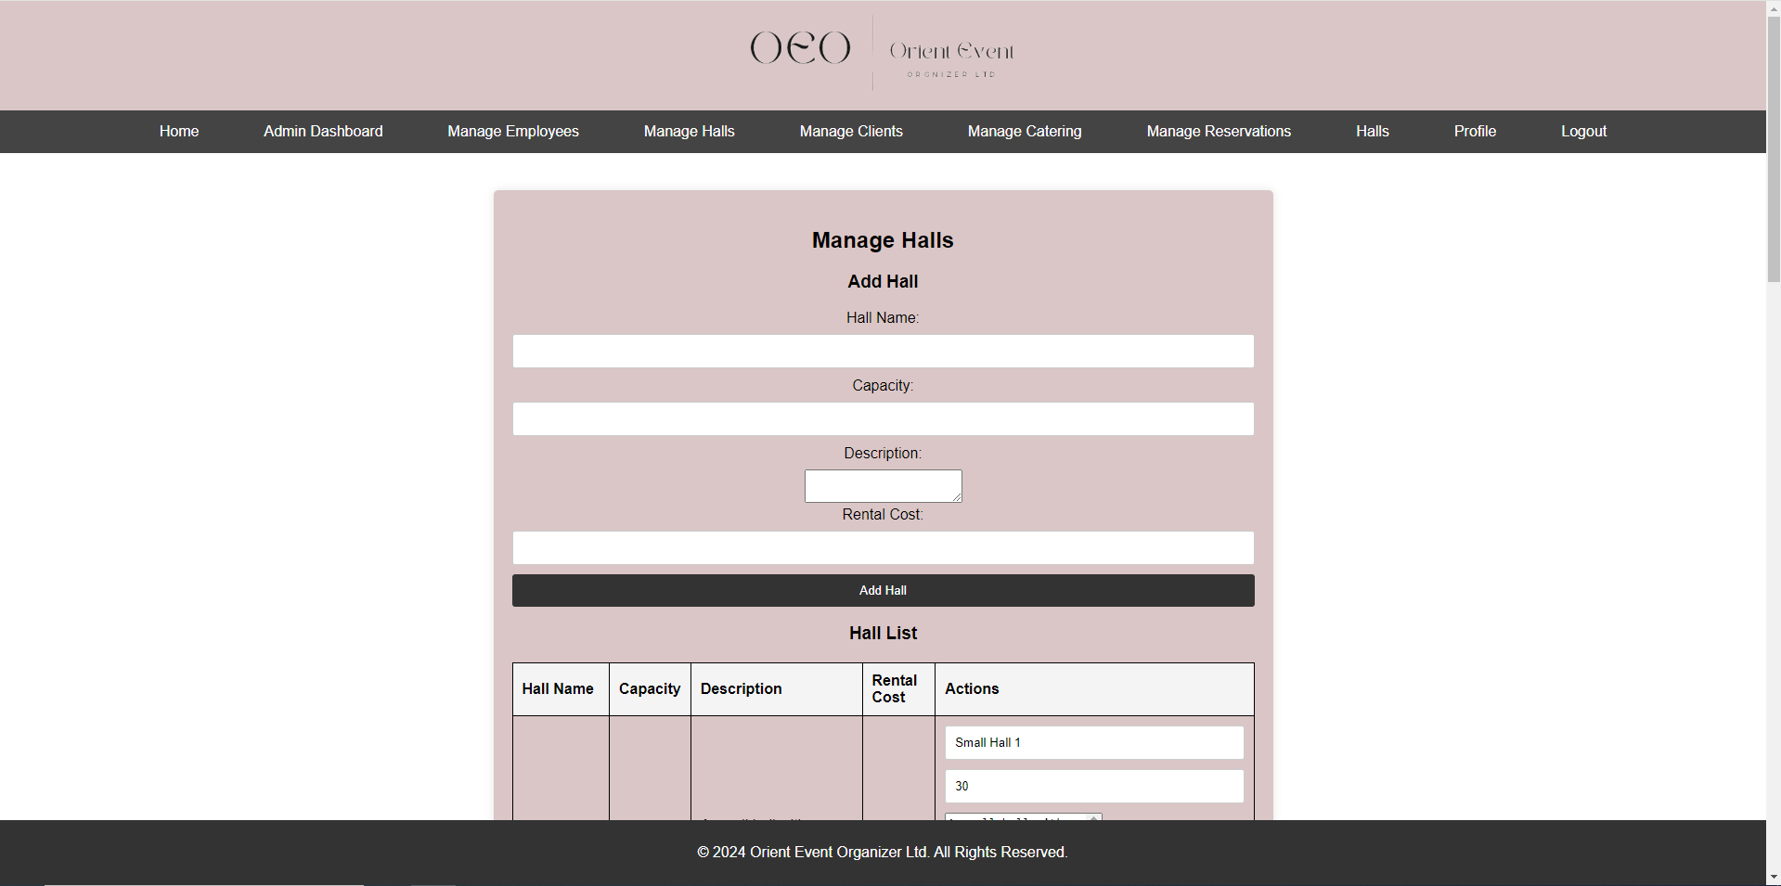

-Manage and View all Client details (add/Edit/Remove)

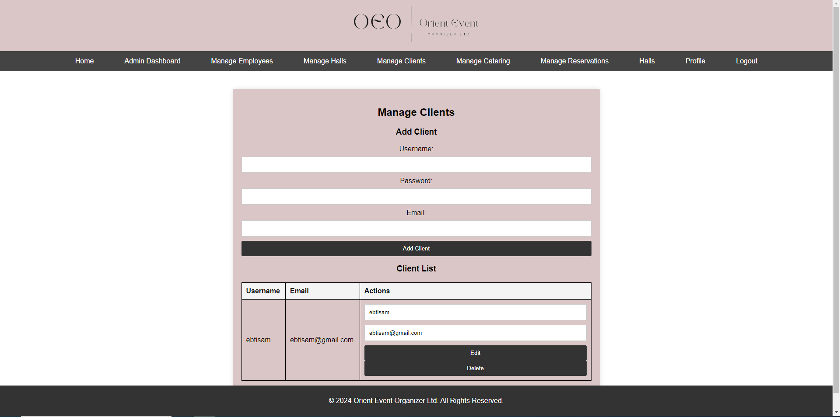

-Manage and View all Catering Menu details (add/Edit/Remove)

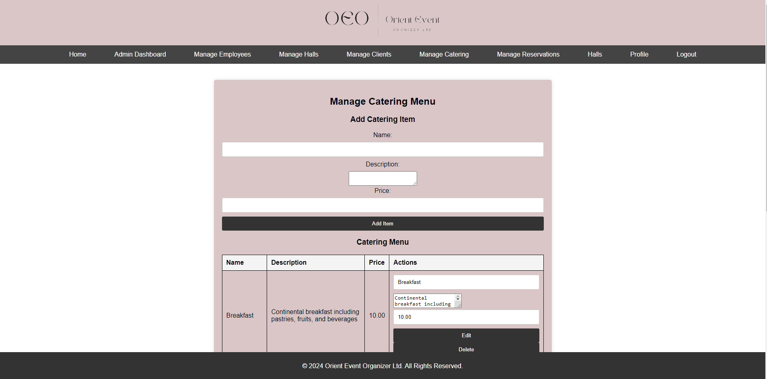

-Manage and View all Reservations details (add/Edit/Remove)

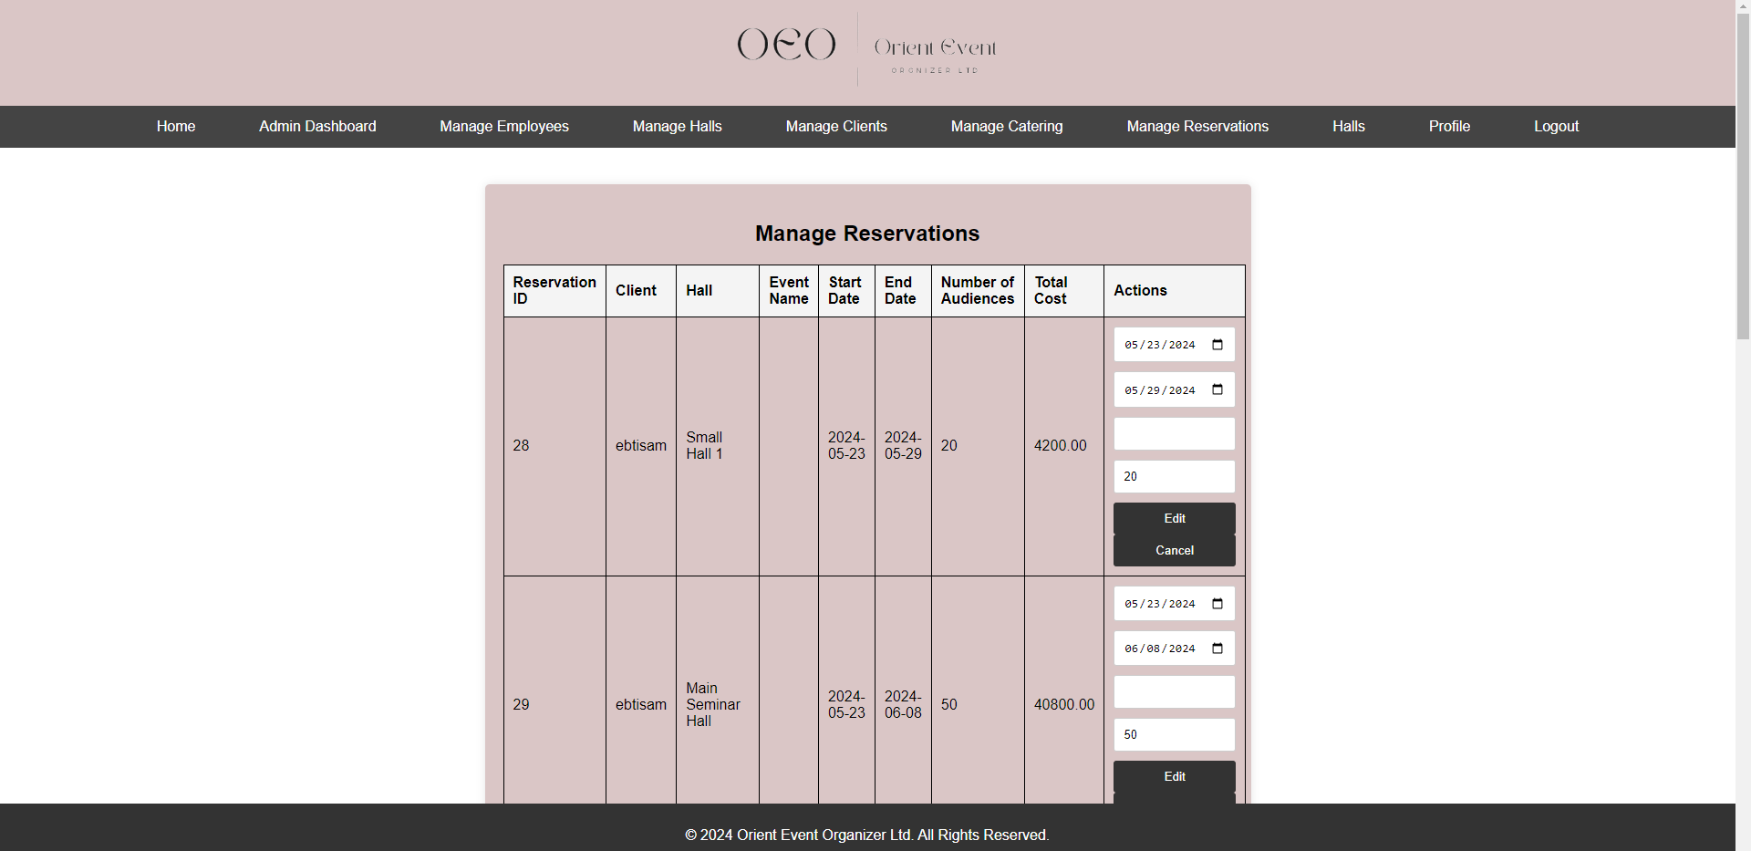

1. **Employee**

-Log in

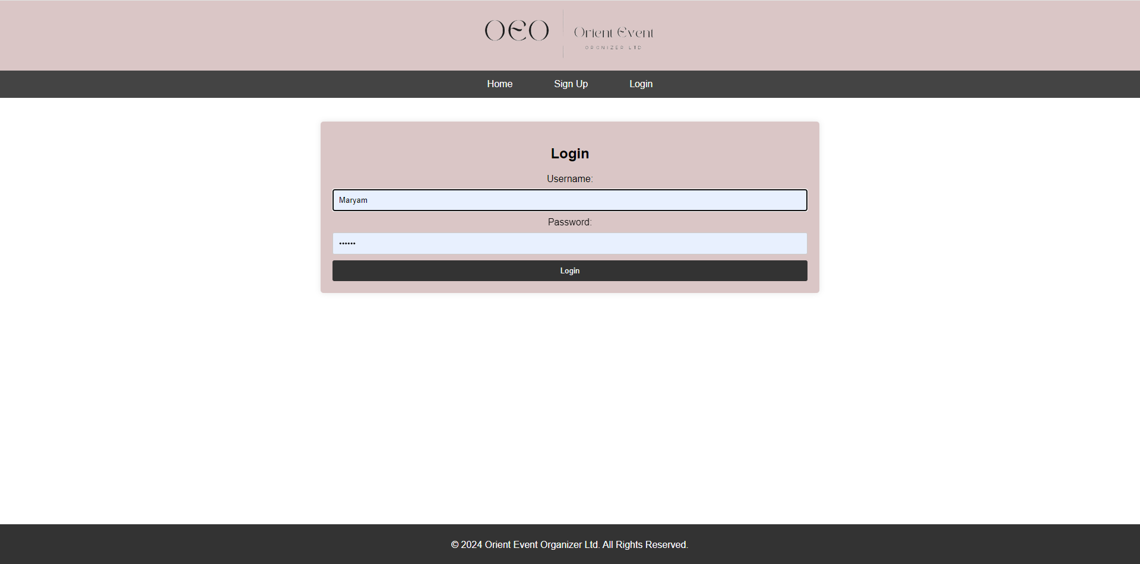

Employee home page

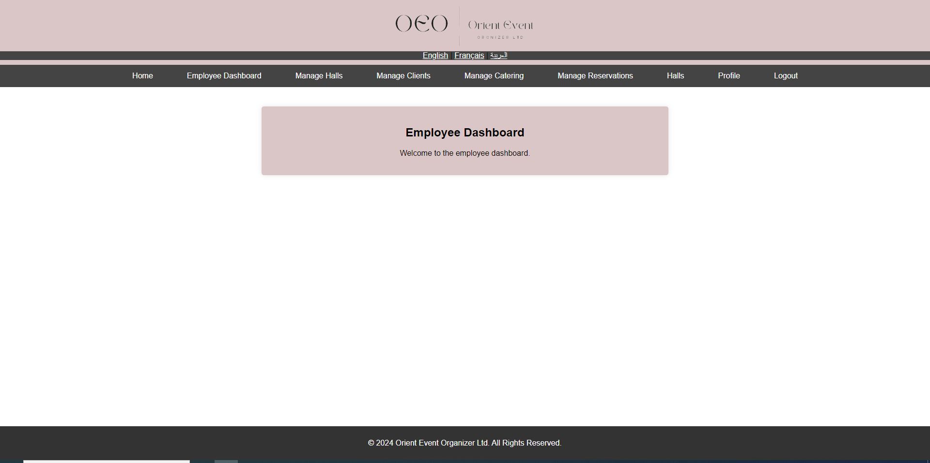

Profile employee page

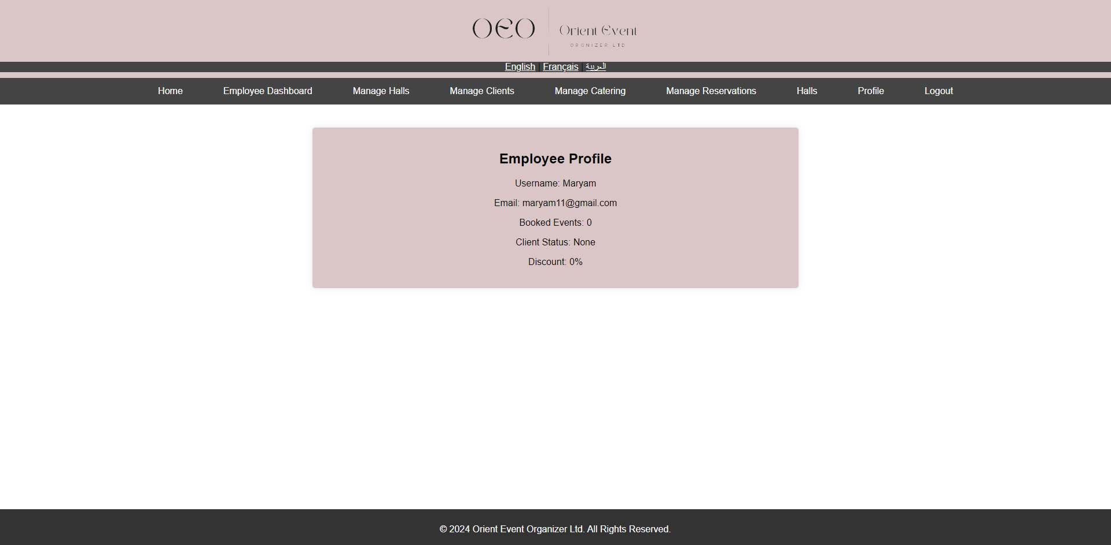

-Manage and View all Client details (add/Edit/Remove)

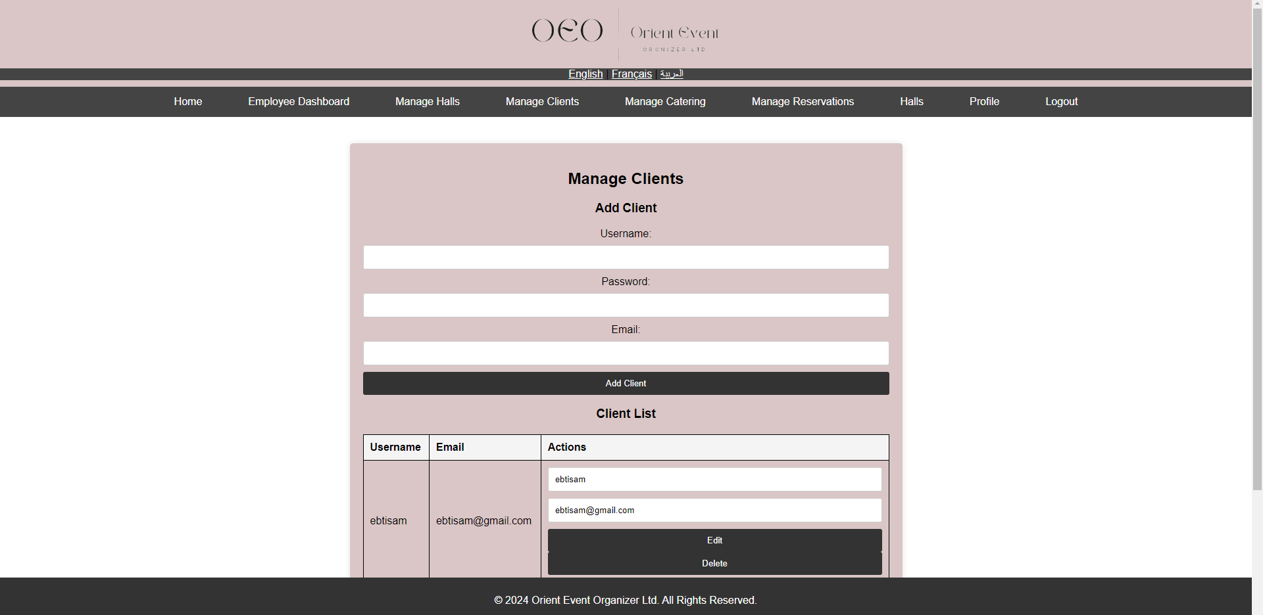

1. **Client**

-Log in and register.

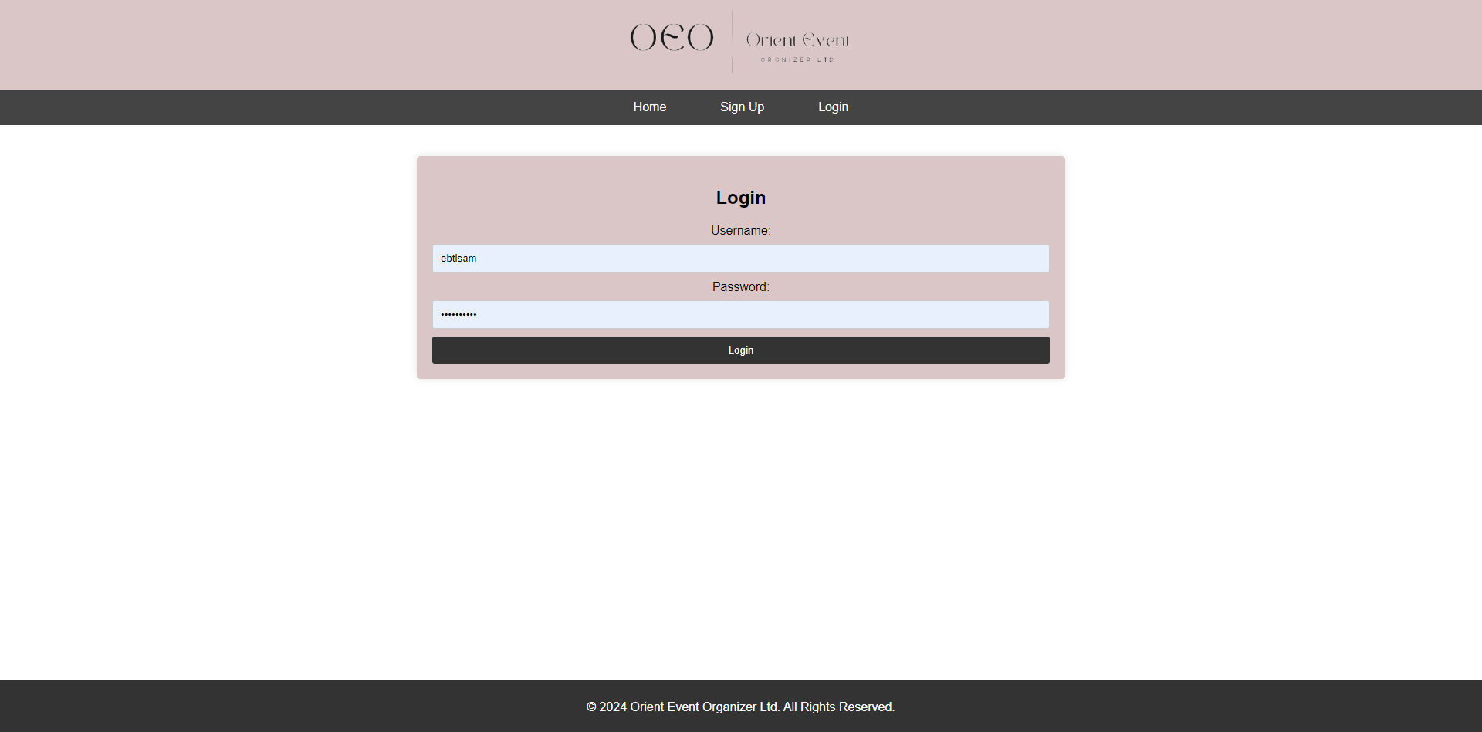

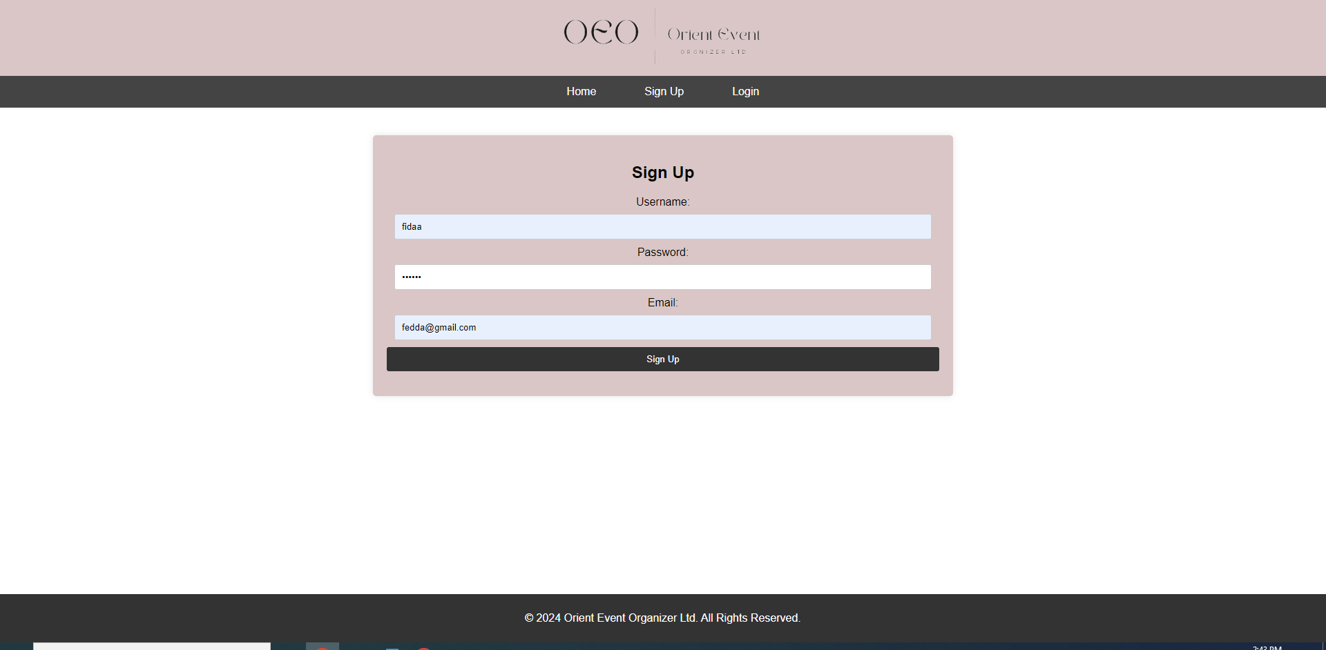

Successfully message shown up left page.

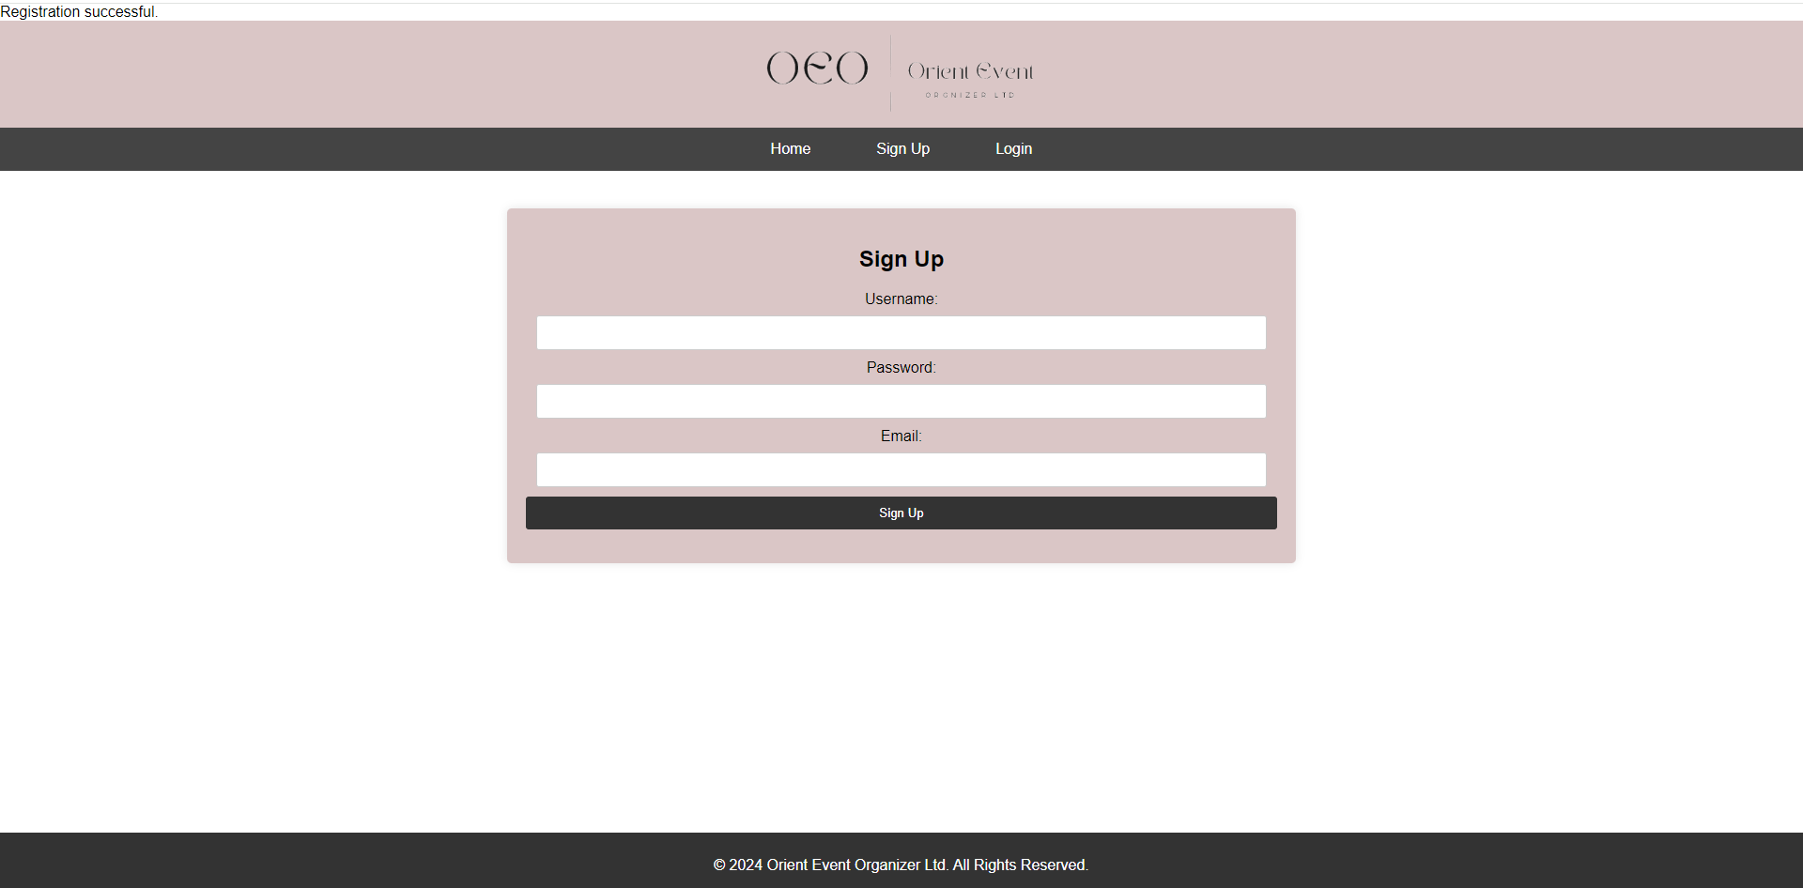

If no reservation:-

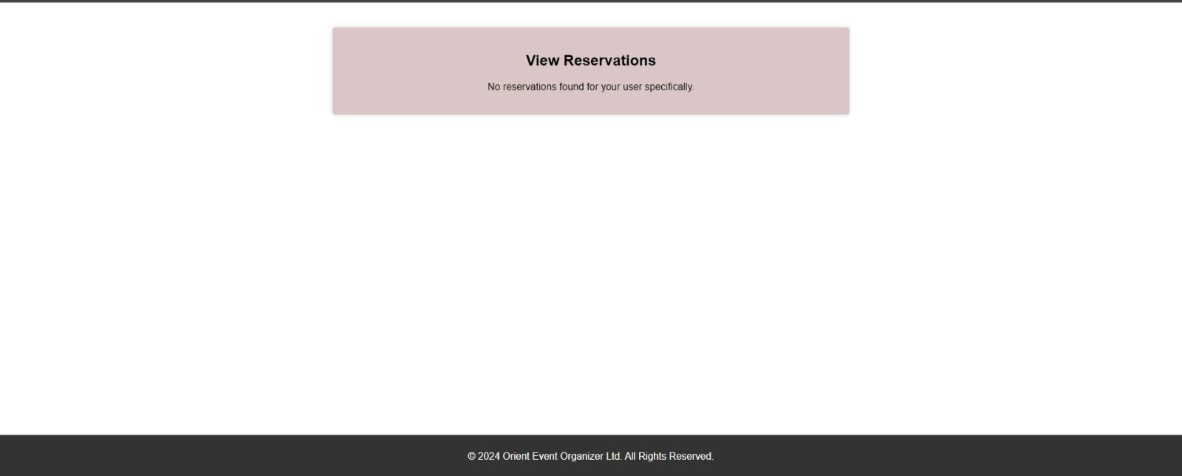

view reservation with a delete button where it is possible to cancel reservation:

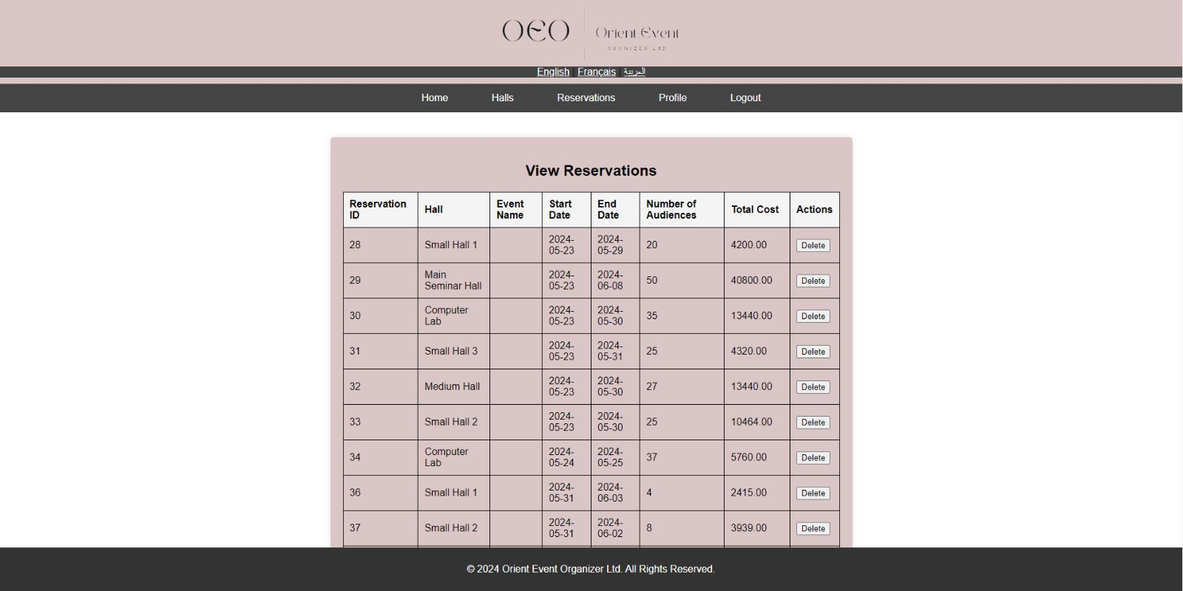

-View halls details (add/update/Remove)

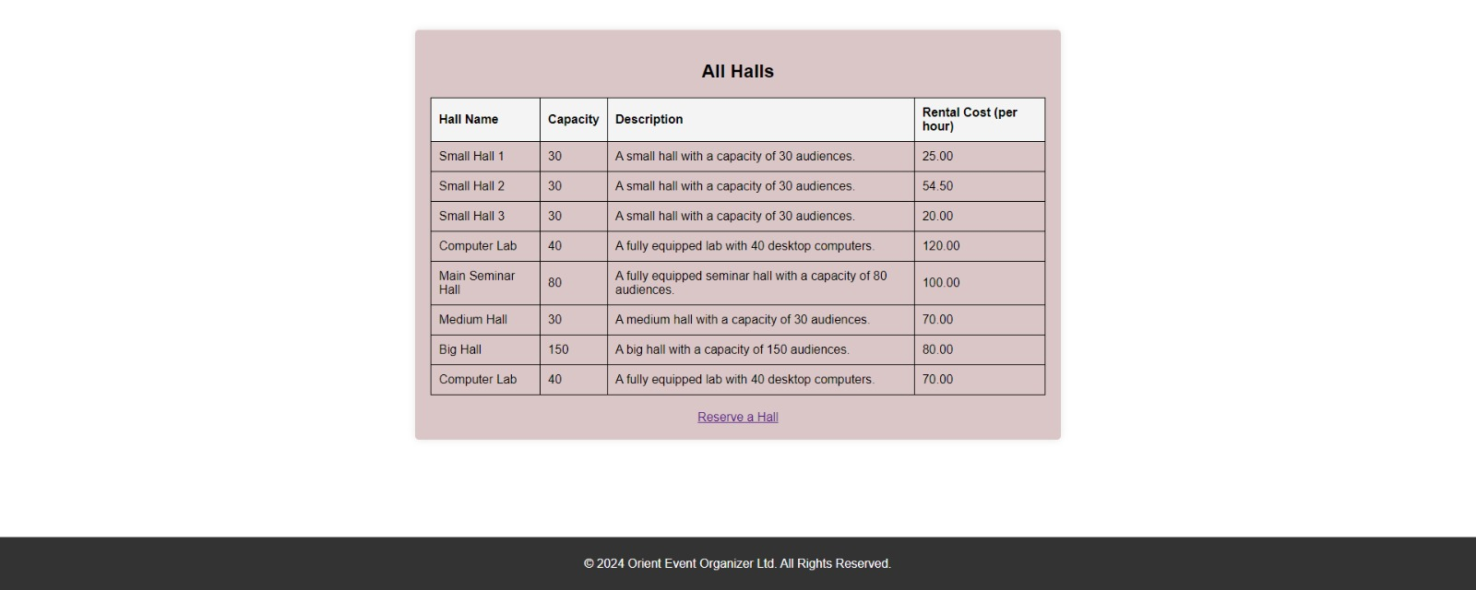

After clicking on “Reserve a hall” to search

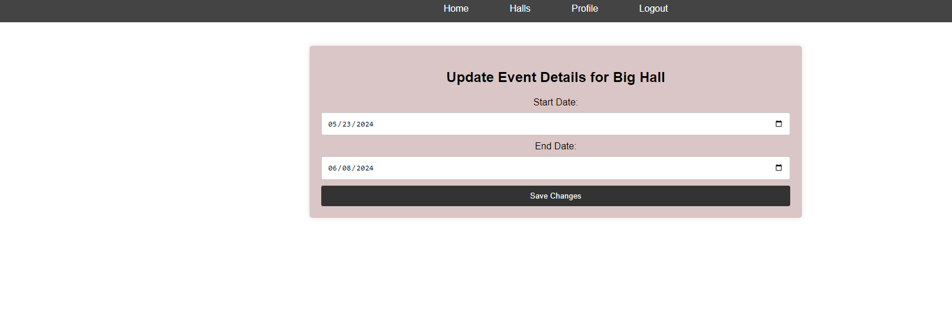where client can update details or cancel it.

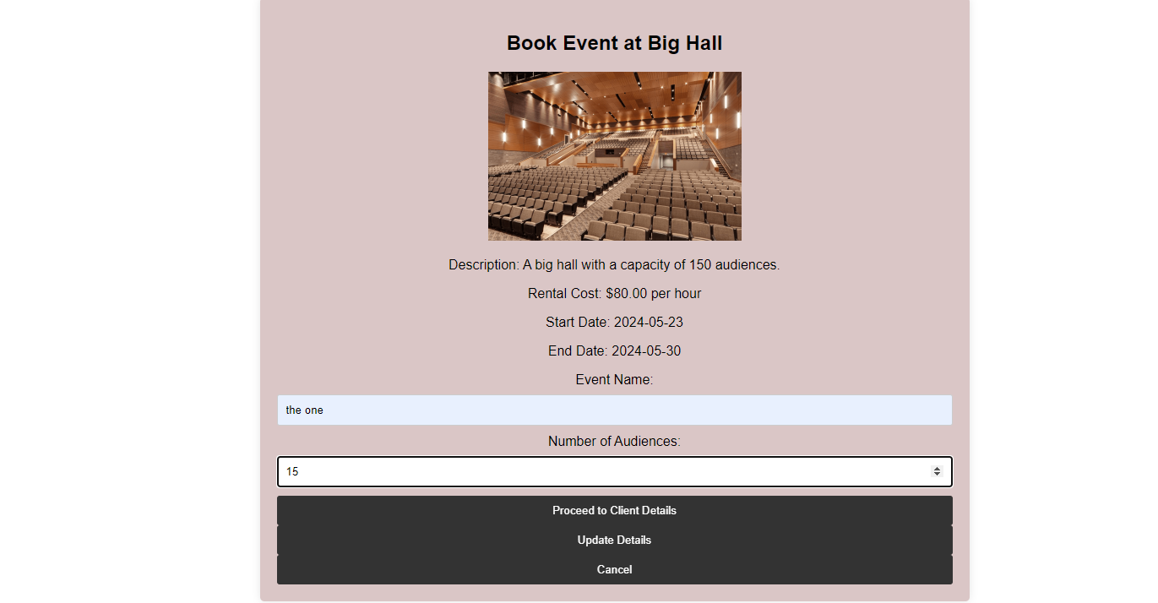

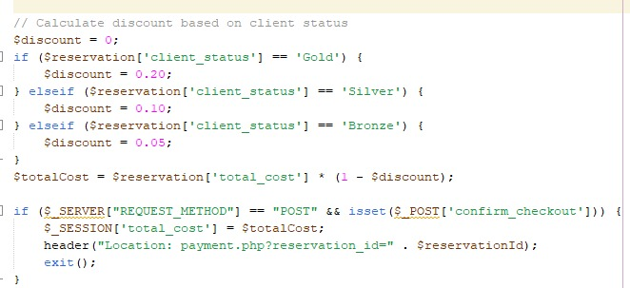

-The Hall reservation dates should be updated accordingly if the Client cancels the reservation, and the Hall must be available for the next reservation.

In the search, the list of available halls that shows after the user clicks the search button changes based on the availability of the hall on the specific dates. So, if another user has already reserved a hall it will not show in the list. Moreover, the availability is included in the database as an attribute. It can either be 1 for reserved, or 0 for available.

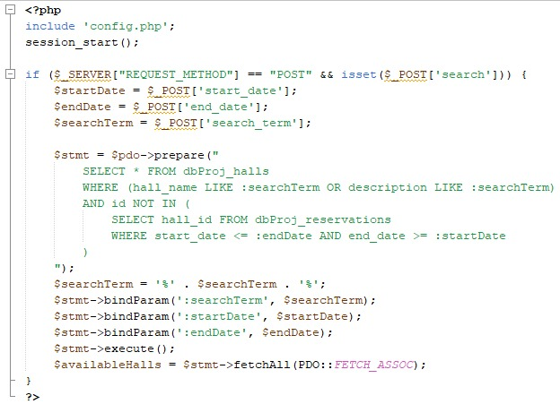

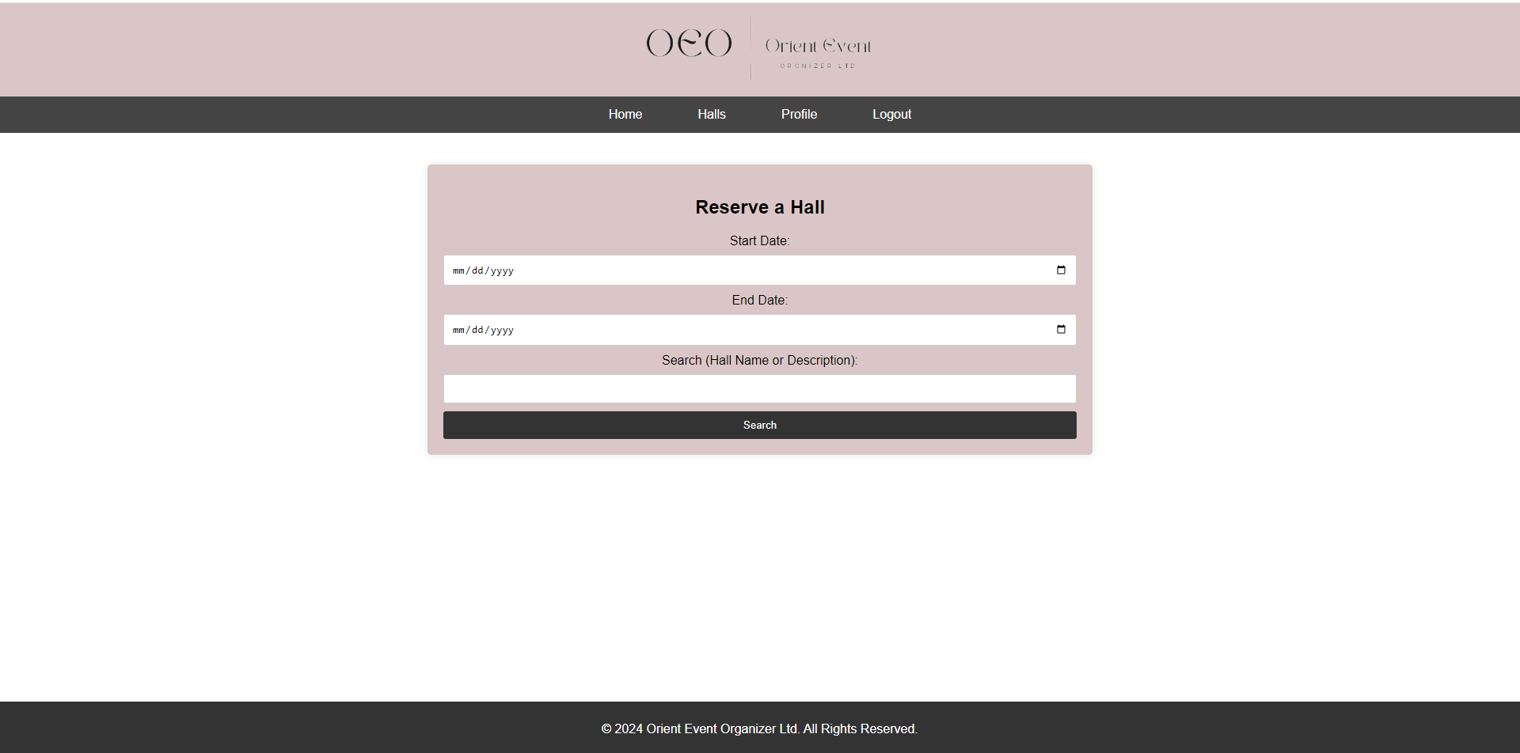

-The reservation number sent to the client will allow the client to access their reservation details if they wish to modify their reservation details using the unique number below.

Reservation code

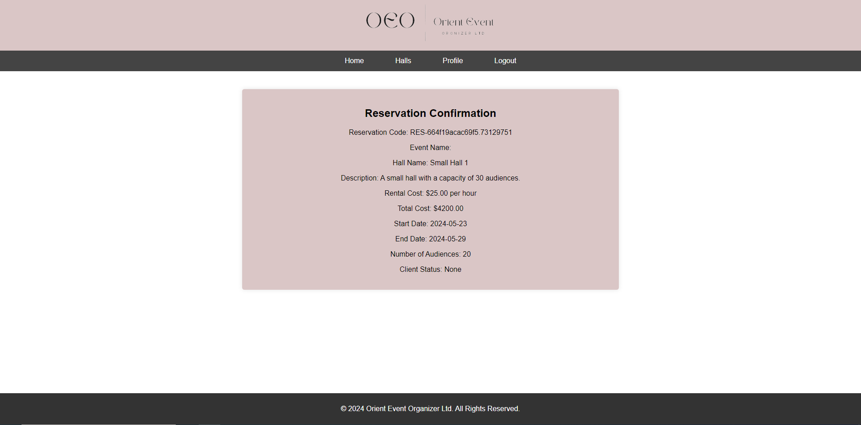

-The client will be allowed to amend reservation details up to two days before the actual date of the event but will be charged 5% of the overall cost.

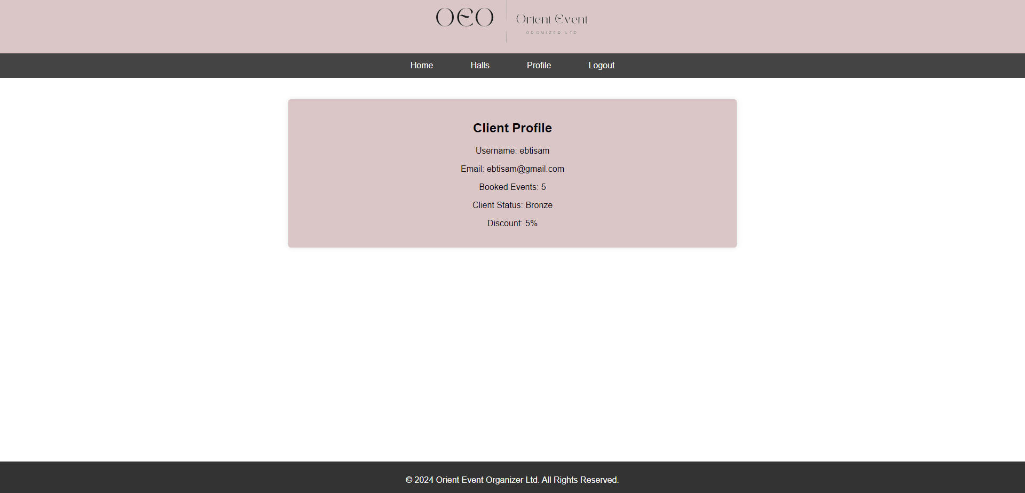

### Online website

## Non-Functional Requirements

### **• Navigation**

Easy to use, centered, well designed and appealing.



### **• Pagination**

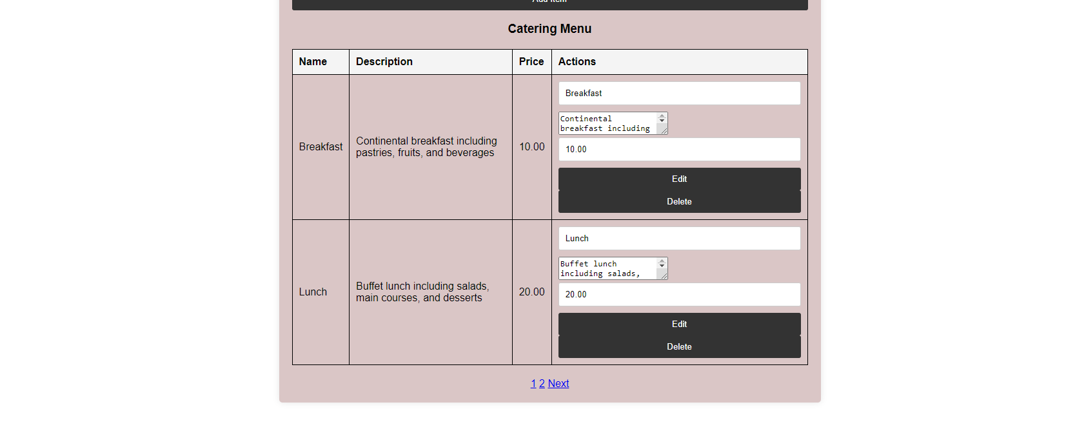

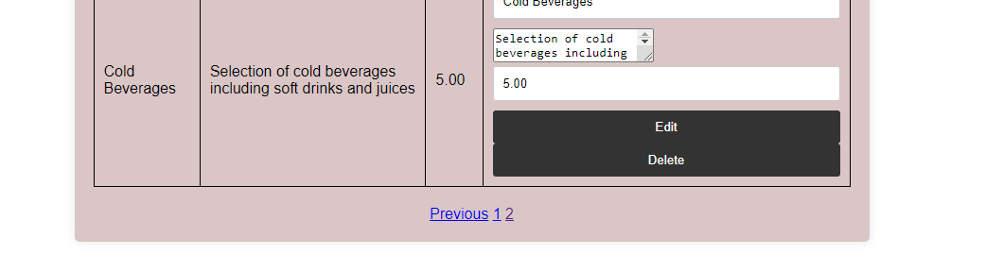

### **• Look and feel**

Easy to use, centered, well designed and appealing. Also, clean and modern design, unique logo and well-designed layout and structure. Button are varied and efficient.

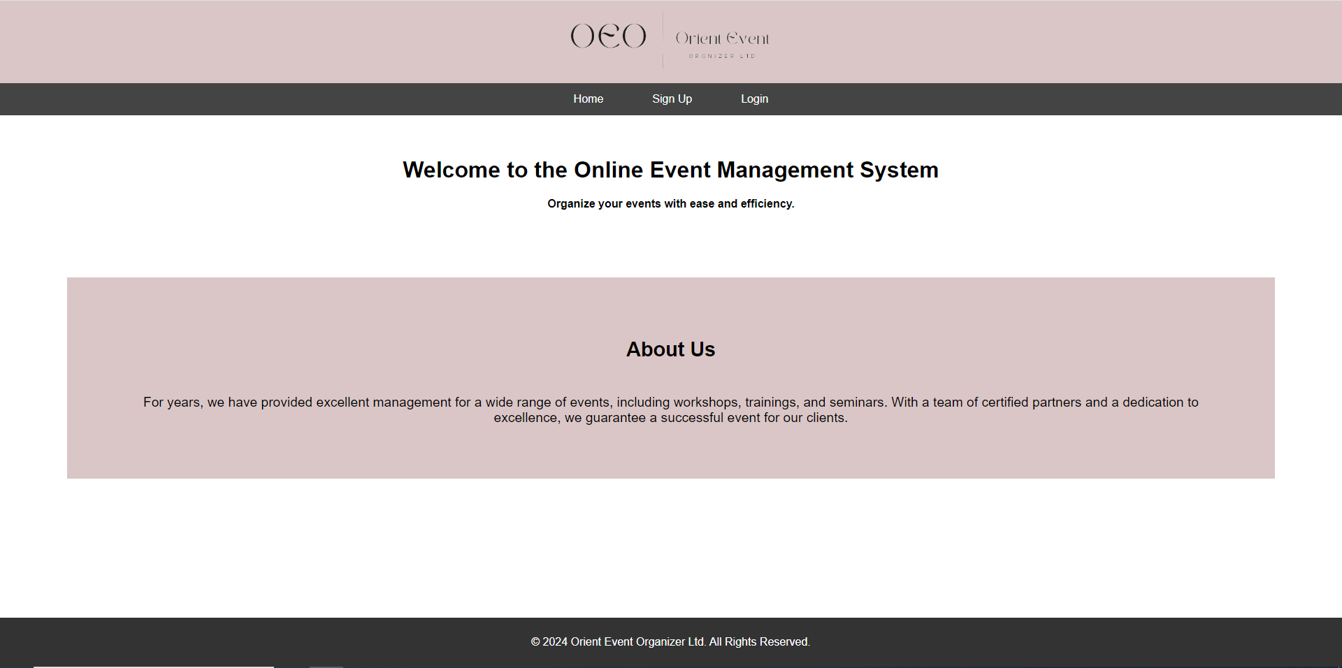

We can resize description input area

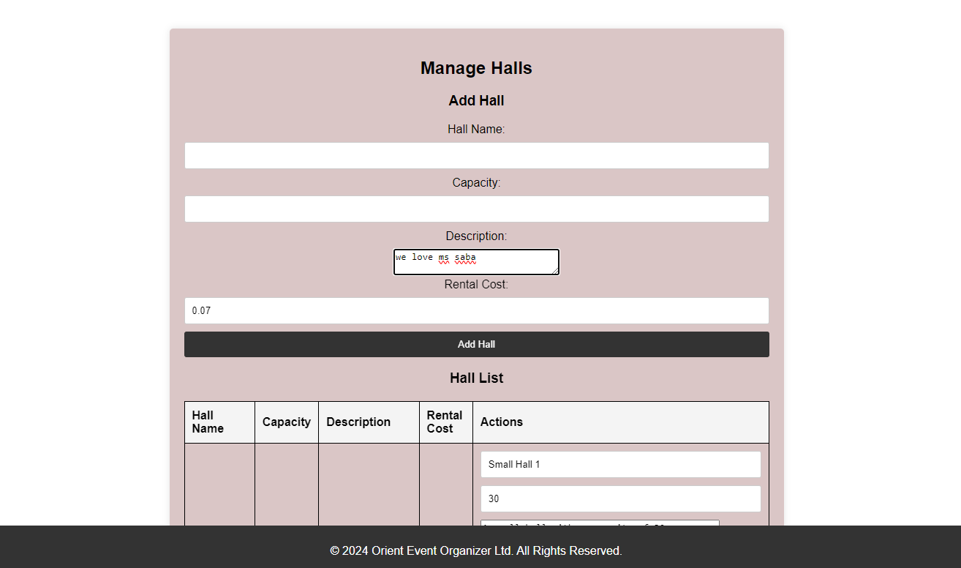

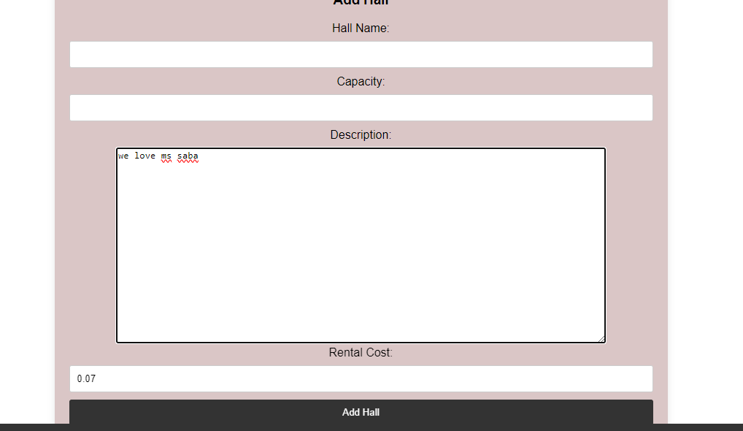

User can choose date from the calendar

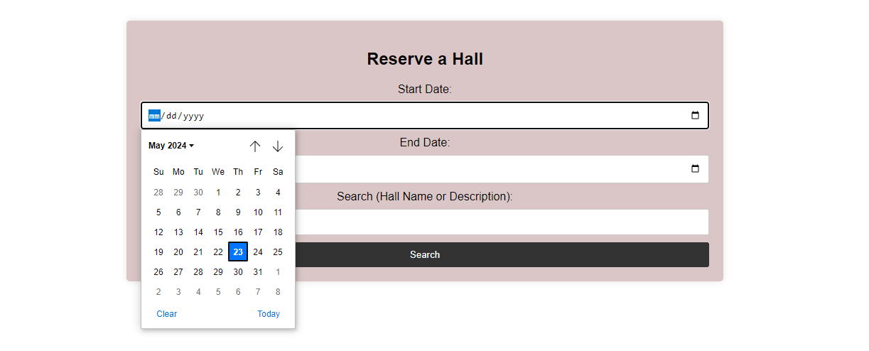

We can click the arrow to increase or decrease price

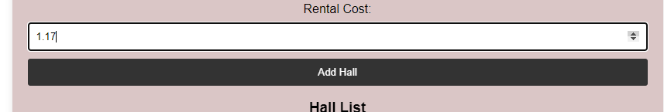

### **• Validation of input**

Success message for register



Validation for password for more than 6 characters

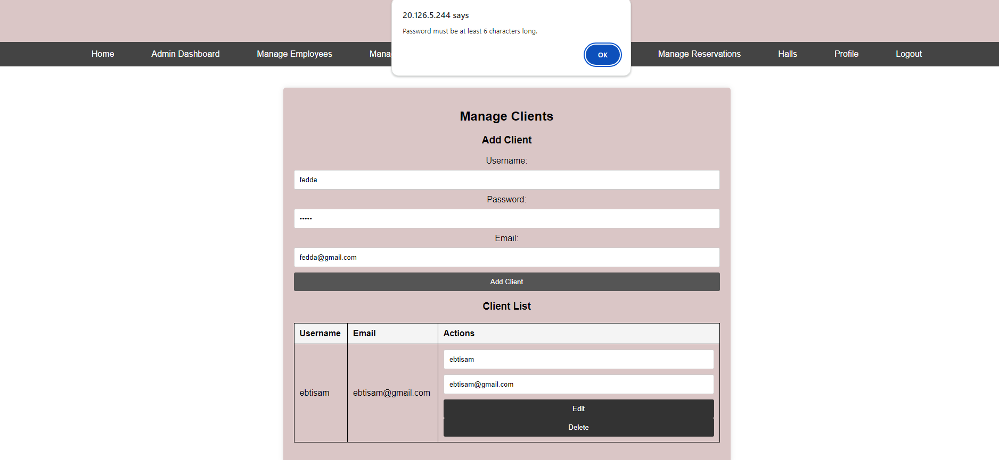

Required field should be entered

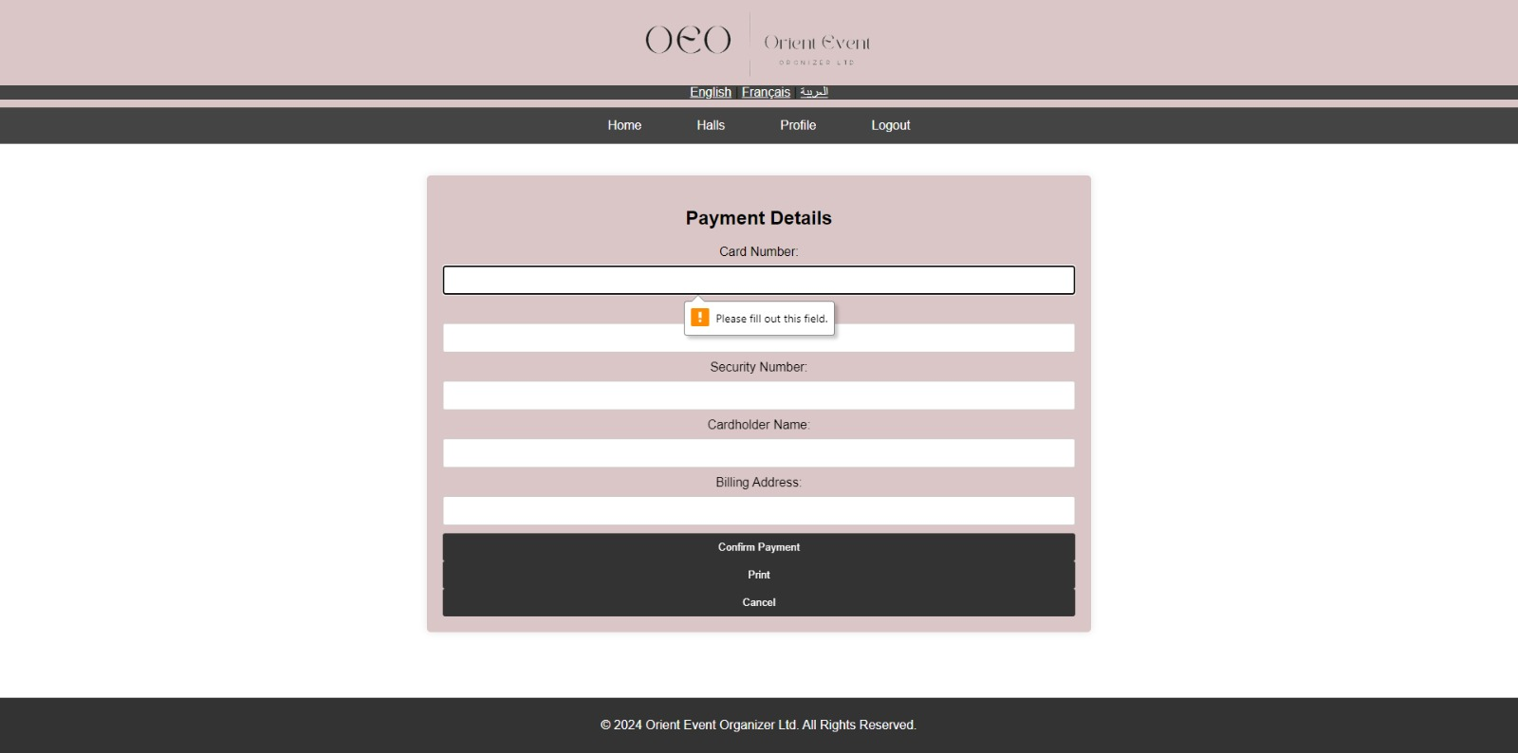

If there is any error in the page it will display a pop up that something occurred using Jquery and ajax

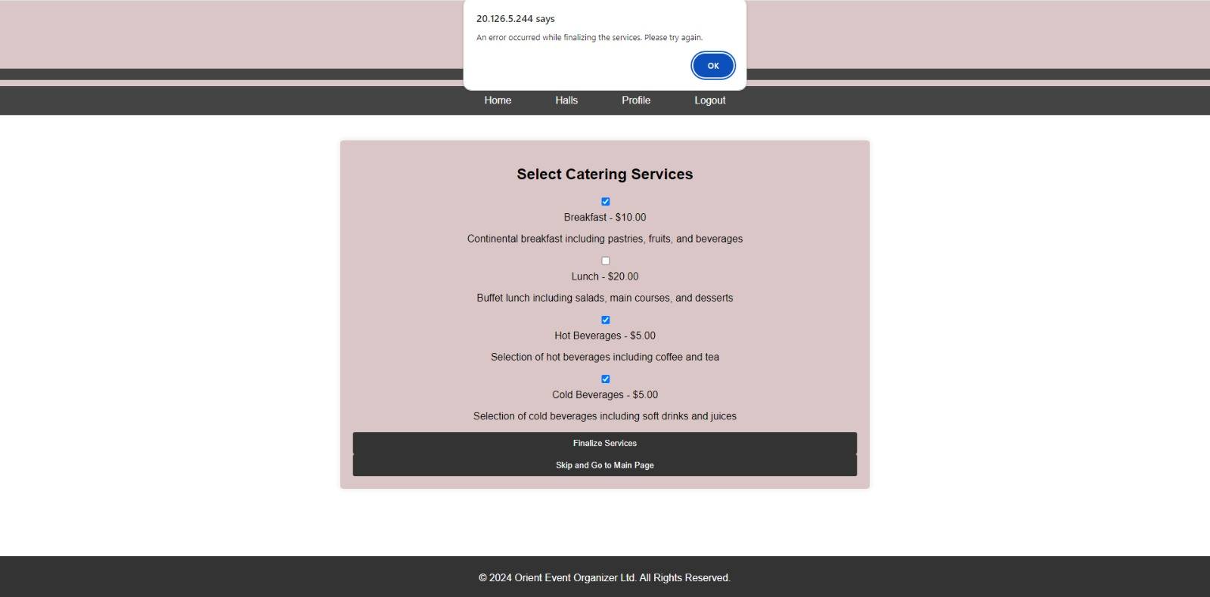

### **• Extra printing**

We do not have random errors in the website and everything works well with validation, we also included receipt and extra printing.

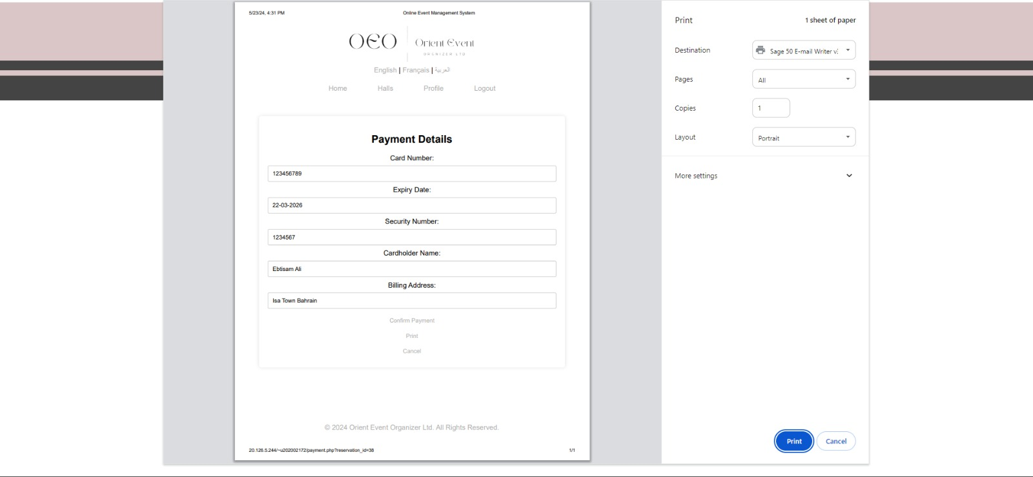

# **Database**

Screen Shot of ERD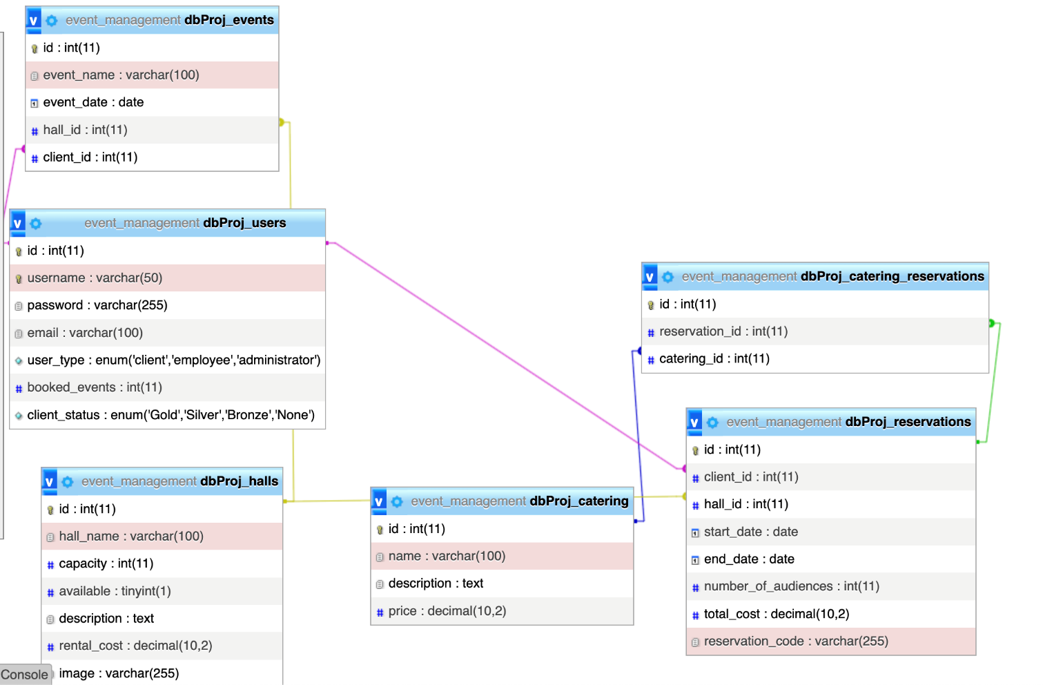

## Procedure

Amending Reservation Details

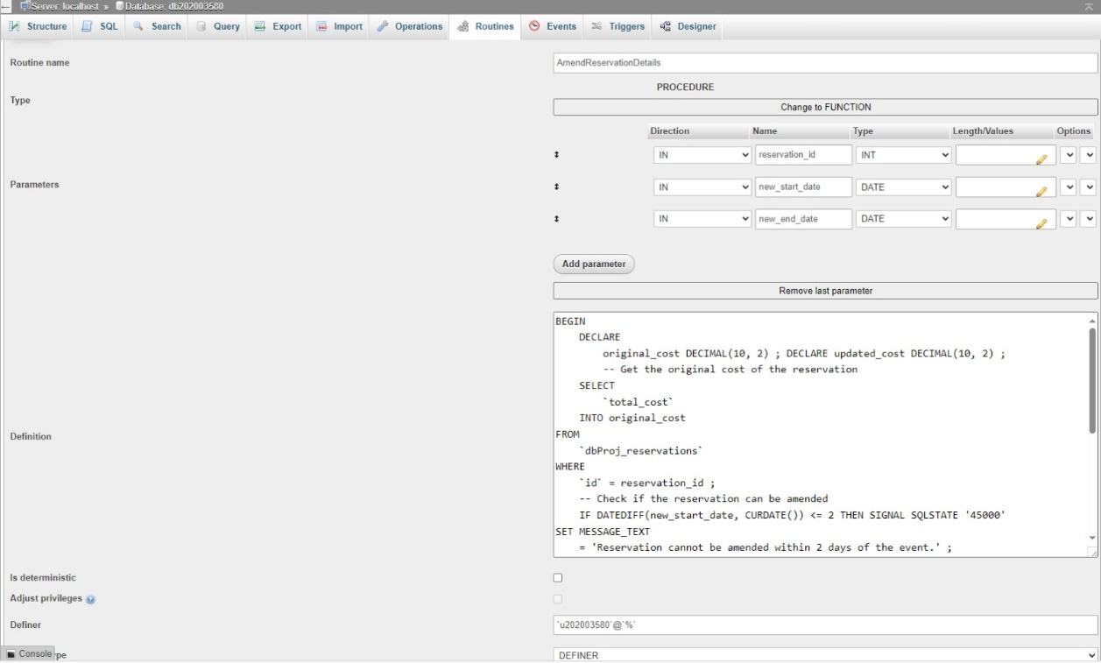

Enter Personal/ Business details to Confirm Reservation

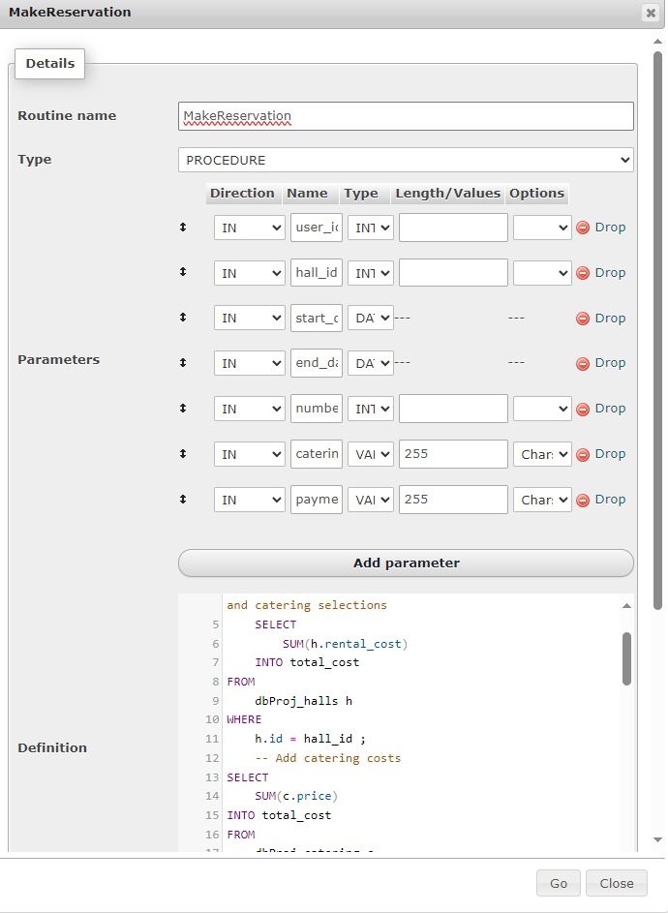

Index Searching and Full text Searching

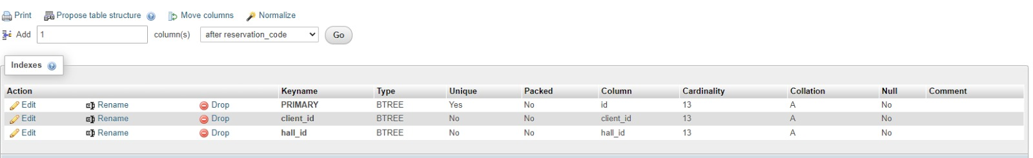

This SQL statement adds a full-text index to the dbProj_halls table, indexing the hall_name and description columns. This index will enable full-text searches on these columns, allowing to perform efficient text searches.

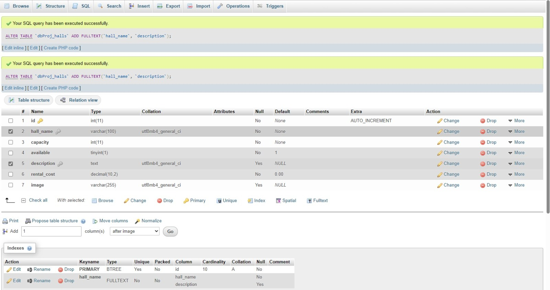

## DB Security techniques used

Strong Password Policies as it is

the password encrypted

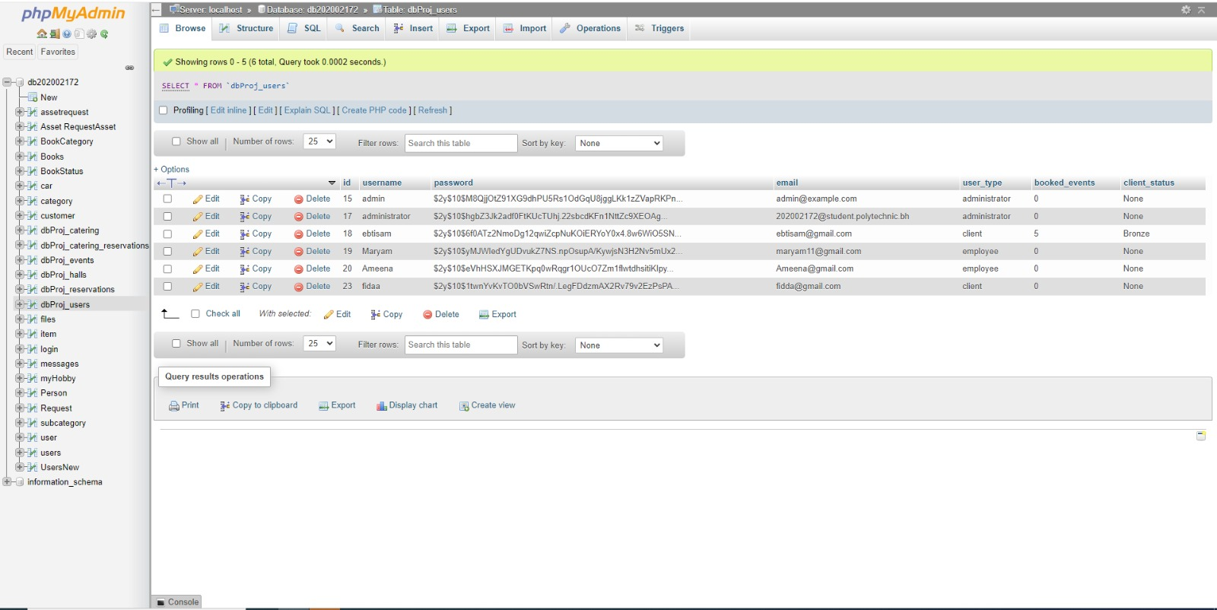

Encryption and decryption of the password

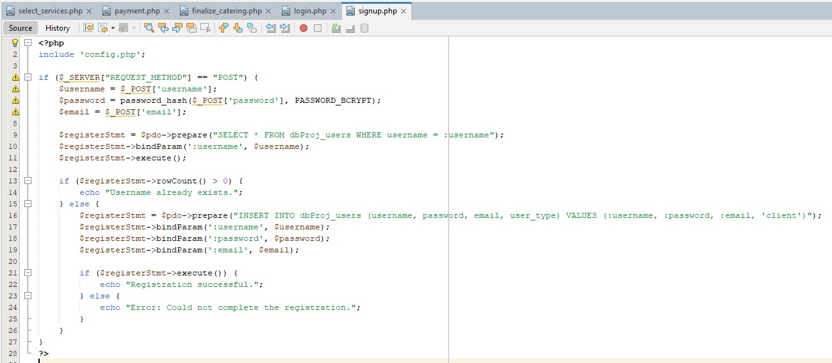

# **Users for testing**

* **Admin account:**

Username: administrator

Password: administrator

* **Employee Account:**

Username: Maryam (case sensitive)

Password: Maryam

* **Client account:**

Username: ebtisam

Password: ebtisam234

# **Test Data**

# **Advanced features used**

* Advance level Web Application Design

Our website is user-friendly and scalable, designed to provide a seamless experience across different screen sizes with a clear and minimalist layout. The responsive design ensures that the website adapts perfectly whether viewed on a mobile phone, tablet, or desktop. Additionally, our website features a robust search functionality, enabling users to easily find what they need. The content is presented in a readable and understandable manner, adhering to best practices for accessibility and usability. This ensures that all users, including those with disabilities, can navigate and interact with the site effortlessly. We also included the printing receipt “Print” button for advance feature:

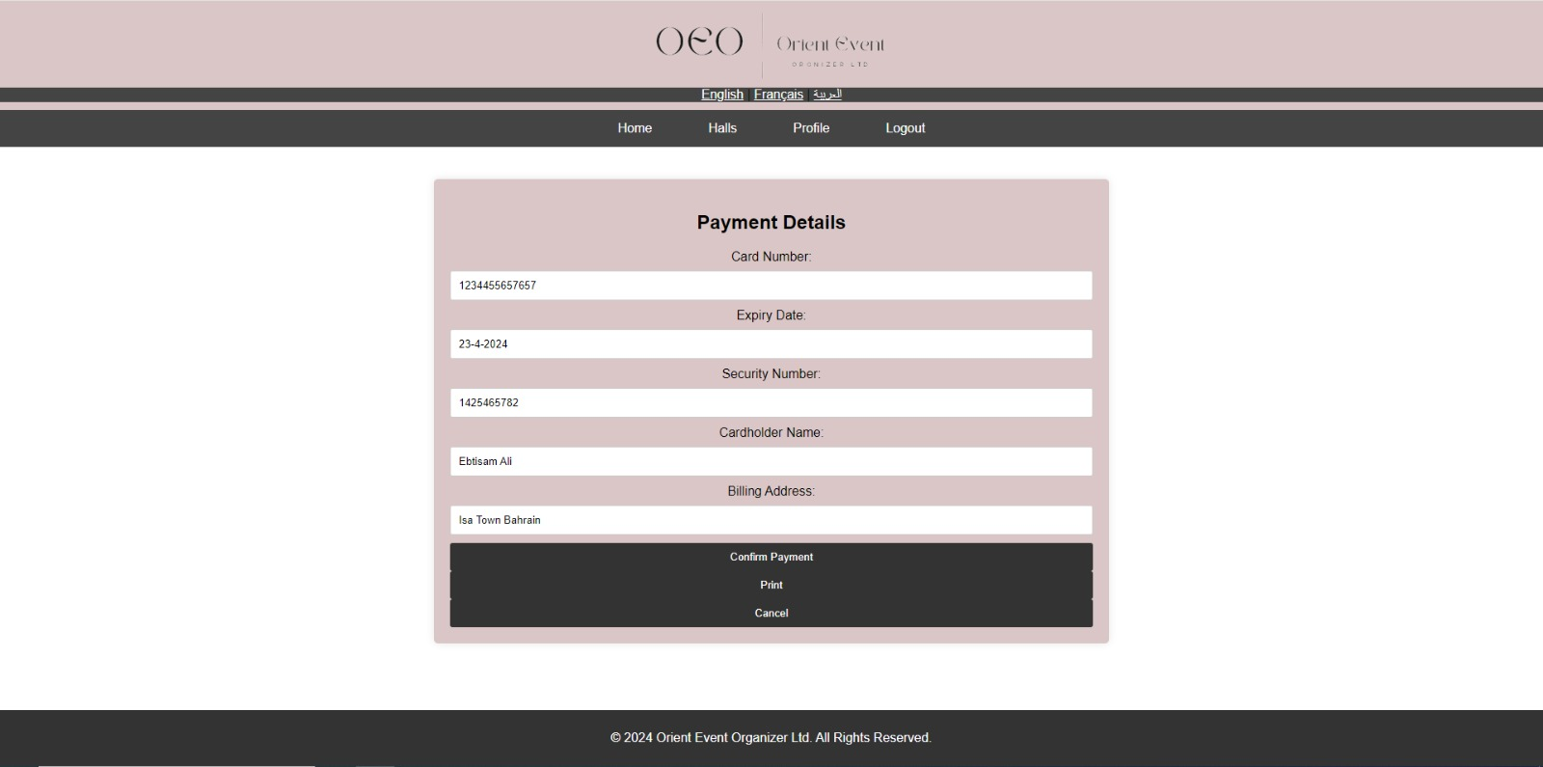



* Localization

Default language or English button

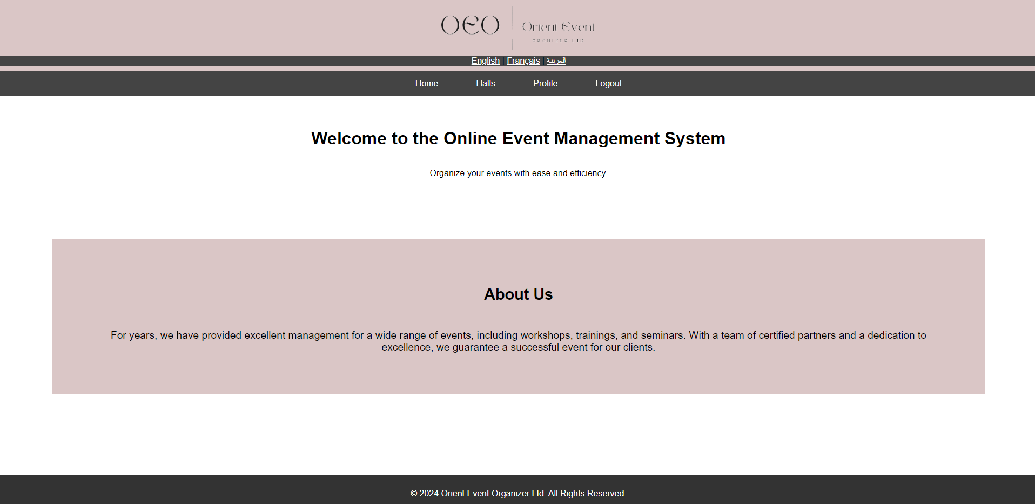

Arabic button

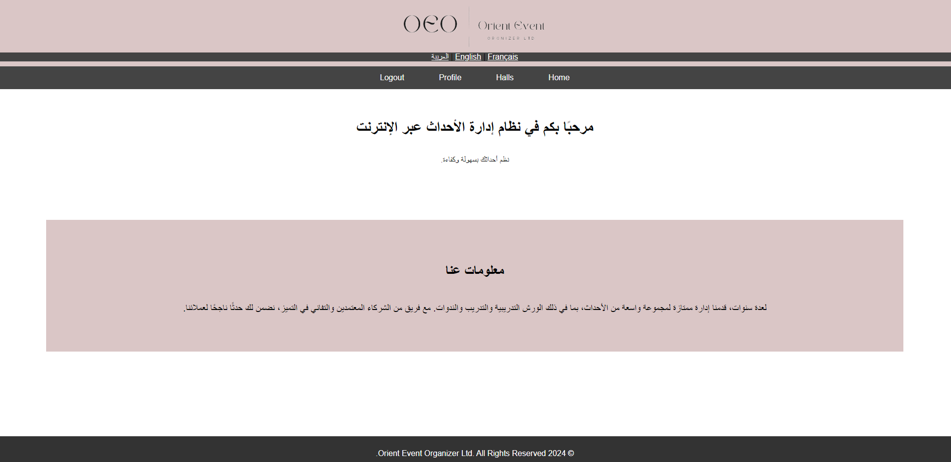

French button

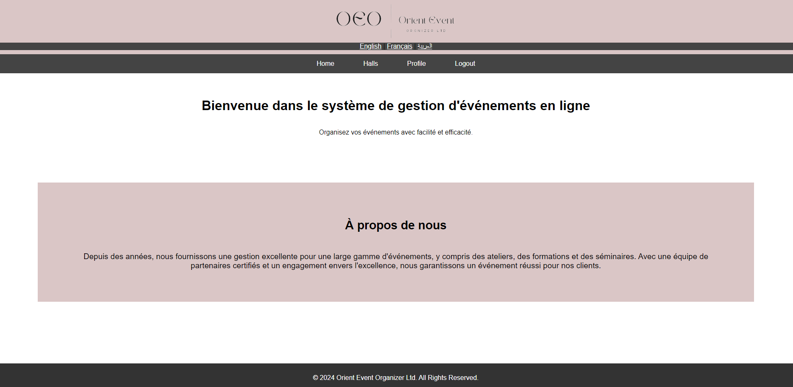

* Prepared statements

the code contains a prepared statement for securely querying the database with user input using prepare method and binParam.

